**TABLE OF CONTENT**

1 WEBSITE DESIGN 2

2 GRAPH REPORT 3

3 TABLE REPORT 4

4 Fitness - Settings 6

5 Fitness FOMULAE 8

Heart rate Exercise 8

Target heart rate for single mode 8

Target heart rate zones for multi-stage mode 8

Target HR zone calculation 8

Multi-stage Heart rate Exercise Programs 8

Pedometer 9

# WEBSITE DESIGN



[Feature 05: Fitness](System%20Feature%20formulae-ver%200.1.2.docx)

Chủ yếu là đo đi bộ. **Pedometer: thiết bị đo đi bộ.**

**(**an instrument for estimating the distance travelled on foot by recording the number of steps taken.)

From the Track My Health home page, the user can select the Fitness feature icon.

Once the Fitness feature icon is selected, the user will be directed to the Fitness page. On the Fitness page, the user will see a Graph button and a Table button; below the Track My Health and Fitness sub-headers.

# GRAPH REPORT

If the user selects the Graph button, the user will see a Fitness graph with an x-axis and a y-axis.

The **x-axis** will reflect

the date/time of the data recordings, while the

y-axis will show several variables; such as

**Step counts,**

**Distance,**

**Average speed,**

**Calories burned, and**

**Pedometer duration.**

[Please refer to the formula document for further details on any parameters, or measures, listed in this section.](System%20Feature%20formulae-ver%200.1.2.docx)

The user will be able to select the desired y-axis variable via a drop down box above the Fitness graph.

Above the graph, the system will display a notification stating "Select parameter to draw." A drop down box, with the y-axis variables, will be positioned to the right of the notification.

**BODY OF GRAPH**

Within the graph, the user will see clustered bars that reflect the data over time (Clustered Bar Graph).

However, if there is no data to display, then there will be a notification that states "You have no data to graph." Nonetheless, if there is data to display, then **each piece of data will be represented by a color**.

For example,

the bar on the left will be orange, and will represent Step counts.

On the other hand, the bar on the right will be green, and will represent the target for each y-axis variable selected.

This will be reflected in the **legend** to the right of the graph, which details the variables and corresponding colors.

Below the graph, the user can select the Date/Time section to display a pop-up calendar. This will allow the user to select a desired start and end date/time.

# TABLE REPORT

Aside from a graph, the user can select the Table format.

Below the Table button, the user can select

**+ the Heart Rate exercise table link (HR exercise table), or**

**+ the Pedometer table link.**

**HR exercise table**

On the HR exercise table, the system will display several columns to represent

**Date/Time,**

**Duration,**

**Exercise,**

**Time in zones,**

**Target HR,**

**Average HR,**

**and Maximum HR.**

**the Pedometer table,**

system will display several columns to represent

**Date/Time,**

**Target,**

**Steps,**

**Distance,**

**Average Speed,**

**Calories burned, and**

**Duration.**

Under each table header (i.e. Date/Time, Duration, etc.), there will be several entry fields to reflect the data collected over time for each category.

For the Date/Time field, the user can select Date/Time and a pop-up calendar will display for the user to select the desired start and end date/time.



**There is a second table** which reports the **daily pedometer** data. This table will display similar fields as the first Pedometer table.

**Diagnosis section**

Below the graph/table section, the system will display a Diagnosis and Recommendations field.

Initially, the Diagnosis and Recommendations section will have a notification that reads "This page displays your current medical issues and the date that they were noted in your medical record. Click on the issue name for more in-depth information on that particular issue."

By following the notification directions, the user will be able to retrieve details about their current diagnosis and previous diagnoses. It will also detail recommendations based on the diagnoses provided.

**BUTTONS**

Beneath Diagnosis and Recommendations, there will be a **Settings button** and a **Back to Track My Health button**.

If the user selects the Settings button, they will be directed **to the Fitness Settings page**.

However, if the user selects the Back to Track My Health button, then they will be transferred **to the Track My Health home page**.

# Fitness - Settings

On the Fitness Settings page, the system will display a **notification**, under the Fitness Settings sub-header, that states "This page displays the current settings of this feature."

Below the notification, the user will see **two sets of settings categories** that the user can change.

The first set of settings pertains to **Heart rate exercise**.

Under Heart rate exercise, the user can modify the

**Exercise mode,**

**Target HR method, and**

**the Custom exercise programs.**

[Please refer to the formula document for further details on any parameters, or measures, listed in this section.](System%20Feature%20formulae-ver%200.1.2.docx)

With the Exercise mode setting,

the user can select

**single** only one Target Heart rate value during the exercise

**multi-stage**. There are multiple stages during the exercise. Each stage can be set with different Target Heart rate Zone and Time.

For the Target HR method,

the user can select General or Zoladz.

Under the Custom exercise programs setting,

the user will be able to pull up an exercise program table.

exercise program table

Above the table, there will be a **box that details the number of stages**.

To the right of the box, there will be a **Save button** for the user to save any changes.

Within the table,

|  |  |
| --- | --- |
| **HEADERS** | there will be three headers listed from left to right; namely, |
| **Stage** | Under Stage, the system will display  fields for  Warm up,  Fat burn, and  Recovery |
| **Target HR** | Below Target HR, the user will see  boxes for  Zone 1 or  Zone 2 |
| **Time** | beneath Time, the system will display **boxes** with time intervals; for example, 5, 10, or 20 minutes. |

Under the table, the user will see a **split box** that details "Transition Audio:" on the left and "file" on the right.

Below that box, there will be another **split box** that details "Program name:" on the left and "Daily" on the right.

The boxes on the right side can be categorized/labeled as the user desires.

**there are the Pedometer settings;**

such as

**Target setting,**

**Remind setting, and**

**Calories burned method.** [**(see formulae)**](System%20Feature%20formulae-ver%200.1.2.docx)

**Keytel05 method**

**Dugas05 method**

For each category, the user can choose the desired settings.

Each category will have different settings that the user can select from to effectively track their Pedometer data.

**BUTTONs**

Below the Fitness settings, the user will see **Edit, Cancel, Save, and Back buttons**.

If the user chooses to edit their settings,

they will need to select the Edit button and make the desired changes.

Once the changes are made, the user will select the **Save** button so that the desired settings are saved.

However, if the user wants to **cancel** any changes, then they will select the Cancel button and no changes will be saved.

The user can also select the **Back** button. This will take them back to the Fitness page.

# Fitness FOMULAE

### Heart rate Exercise

There are 2 operating modes:

* Single mode: only one Target Heart rate value during the exercise
* Multi-stage mode: There are multiple stages during the exercise. Each stage can be set with different Target Heart rate Zone and Time.

### Target heart rate for single mode

* General method: Target HR = % Intensity x HRmax

where% Intensity = 65%–85%

* [Karvonen88] method: THR = ((HRmax − HRrest) × % Intensity) + HRrest  
  where % Intensity = 50%–85%

### Target heart rate zones for multi-stage mode

**Zone 1**: Light Exercise – Healthy Heart Maintenance

**Zone 2**: Weight Loss – Burn Fat & Calories

**Zone 3**: Base - Aerobic – Increase stamina & endurance (Aerobic threshold)

**Zone 4**: Conditioning – Fitness conditioning, muscle building, and athletic training (Anaerobic threshold)

**Zone 5**: Athletic elite – Athletic training and endurance (Maximum)

### Target HR zone calculation

* General method: Target HR = % Intensity x HRmax

where% Intensity for

Zone 1: 50% - 60%

Zone 2: 60% - 70%

Zone 3: 70% - 80%

Zone 4: 80% - 90%

Zone 5: 90% - 100%

* Zoladz method: Target HR = HRmax − Adjuster ± 5 bpm

whereAdjuster for

Zone 1: 50 bpm

Zone 2: 40 bpm

Zone 3: 30 bpm

Zone 4: 20 bpm

Zone 5: 10 bpm

### Multi-stage Heart rate Exercise Programs

For Example: if you want to burn fat to lose weight, select your favorite exercise and keep within 60-70% of your maximum heart rate, based on your age, for at least 30 minutes a day, 3 times a week.

* Default exercise program settings: 3 stages

Stage 1: Warm up

Heart rate zone: Zone 1

Time: 5 min

Stage 2: Fat burn

Heart rate zone: Zone 2

Time: 20 min

Stage 3: Recovery

Heart rate zone: Zone 1

Time: 5 min

* Example exercise program: 3 stages

Stage 1: Warm up

Heart rate zone: Zone 1

Time: 5 min

Stage 2: aerobic

Heart rate zone: Zone 3

Time: 20 min

Stage 3: Recovery

Heart rate zone: Zone 1

Time: 5 min

### Pedometer

* Step count: **algorithm** (thuật toán) to get accumulated step count from accelerometer

To implement a pedometer algorithm, follow the steps given below.

1) First go through the sensor datasheet and find what is the minimum sampling rate or BW that it supports. Configure it to lowest sampling rate (Typically 25 Hz is the min range).

2) Now you need to understand all physical movements are within 5 Hz range. So implement a low pass filter of 5Hz cutoff (better use FIR low pass filter). So you can have a FIFO buffer (say length = 5) and filter it.

3) Now you have the meaningful data. Next step is pattern recognition based on **slope** (độ dốc, nghiêng) detection technique. Typically a walk has a positive slope and negative slope with one zero crossing. So you need to identify all three and benchmark a minimum threshold.

4) Keep identifying the above pattern and hold it to check stability and update once you find it is stable.



The TI pedometer algorithm API uses sensor data sampled from the MEMS 3-axis accelerometer at a rate of 50 Hz to detect stepping motion in any axis. This feature allows multiple wearable configurations such as on the waist, in a shirt or pants pocket, or on the wrist.

As motion is detected, the pedometer algorithm starts calculating and accumulating step counts. After thefirst ten (approximately) valid steps have been detected, the step count is updated with the latest stepcount. As motion continues, the algorithm produces an updated step count as each step is taken. If themotion stops, the algorithm resets and waits for the next ten valid steps to be detected.

Ref: http://software-dl.ti.com/msp430/msp430_public_sw/mcu/msp430/MSP430_Pedometer/latest/index_FDS.html

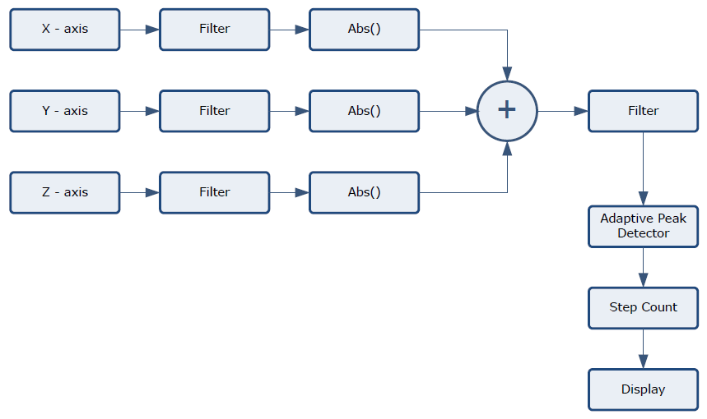

* Step length (inch)

Women: step_length = height x 0.413

Men: step_length = height x 0.415

Or step_length = height x (0.413 + gender x 0.002)

where gender = 1 for male and = 0 for female

* Distance (miles)

distance = Step_counts x step_length

* Duration (minute)

duration = current_time – start_time

* Average Speed (miles/hour)

average_speed = distance/duration

* Calories burned
  + [Keytel05] method: without VO2max:

Men: C/min = (-55.0969 + 0.6309 x HR + 0.1988 x weight + 0.2017 x age) / 4.184

Women: C/min = (-20.4022 + 0.4472 x HR - 0.1263 x weight + 0.074 x age) / 4.184

Inputs: gender, weight[kg], age[years], heart rate[bpm], duration[min]

Outputs: calories[kcal] burned per min, C stands for Kcals

* + [Dugas05] method: without VO2max:

Men: C/min = (-16.1 + 0.194 x HR + 0.311 x pmHR - 0.02 x HR x pmHR - 0.597 x weight + 0.353 x age + 0.007 x HR x weight) / 4.184

Women: C/min = (-20.2 + 0.397 x HR + 0.155 x pmHR - 0.001 x HR x pmHR - 0.174 x weight - 0.08 x age + 0.001 x HR x weight) / 4.184

Inputs: gender, weight[kg], age[years], heart rate HR[bpm], pevious minute heart rate pmHR[bpm], duration[min]

Outputs: calories[kcal] burned per min, C stands for Kcals